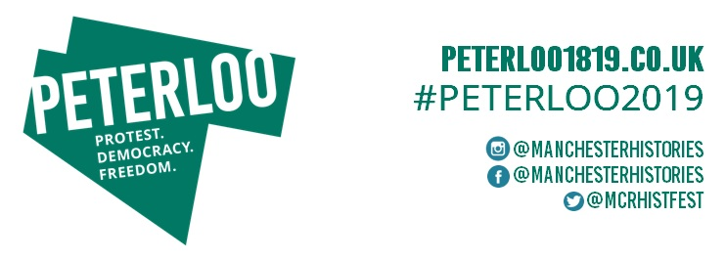

Press release
July 2019
From the Crowd
Marking 200 years since the Peterloo Massacre
Friday 16 August 2019 Peterloo 2019 Anniversary Event #Peterloo2019

From the Crowd is a free, ticketed Peterloo 2019 Anniversary Event taking place at 12:30pm, 5:30pm and 8:00pm on Friday 16 August. Tickets will be released at 9:00am on Thursday 25 July via https://fromthecrowd.eventbrite.co.uk

Exactly 200 years on, just as the people protesting at Peterloo on 16 August 1819 came together, so too will the people remembering those who lost their lives, were injured or were there to seek rights and representation on this historic day. Communities from across Greater Manchester and far beyond will be gathering on the site of St Peter’s Field on Friday 16 August 2019 for the Peterloo 2019 Anniversary Event, a day of music, song, choirs and more, with From the Crowd at the centre; as a hopeful and moving reflection of where this story began.

Throughout the day there will be a gathering of people in performance, voice and spirit. From the Crowd will see members of the public invited to join in and play their part in an immersive experience that will take place at different times throughout the day. Supported using public funding by the National Lottery through Arts Council England and Manchester City Council, it is directed by Evie Manning (Common Wealth) and musically directed by Robin Richards (Dutch Uncles) who have worked with communities and contributors including the Peterloo Ambassadors, Greater Manchester Coalition of Disabled People, These Walls Must Fall, Young Identity and Linda Brogan (playwright and artist). All of the events taking place on the site of St Peter’s Field on 16 August 2019, including From the Crowd, are being co-produced by Manchester Histories, Manchester City Council, Walk the Plank and Brighter Sound.

The eyewitness accounts of those present at Peterloo 1819 and the words of contemporary protestors and poets have been woven together to create a powerful piece that, with no spectators only participants, will come From the Crowd. Collectively they will voice a picture of what happened on 16 August 1819 and the change people want to happen in 2019. At times a single voice will be heard; at times hundreds of voices will amplify the story and charge the atmosphere, all connected to the legacy of Peterloo and what it means today. The soundscape will be set against a musical score, which has been composed and directed by Robin Richards (Dutch Uncles) and will include guest pieces by MC Zani (performed by the Beatbox Collective), Oliver Vibrans and Katie Chatburn.

Evie Manning, From The Crowd’s Creative Director, says, “From the Crowd is a dialogue between 1819 and 2019. In it the words will journey between solo voices, 200 people speaking together and 800 voices strong in unison. The piece explores the power of the crowd, the sense of the unexpected and the galvanising solidarity that manifests when people are together as one. We’ll be remembering those that protested and lost their lives at Peterloo and those whose lives today are affected by different oppressions.”

Helping to lead From the Crowd participants will be 100 people who have volunteered to be ‘Laurels’. The Laurels are a reminder that Peterloo was a peaceful protest, with one group of marchers that made their way to St Peter’s Field from Middleton carrying branches of laurel as a symbol of peace along with their banners that told of their purpose, including
'Liberty and Fraternity' and 'Suffrage Universal'. Amongst those taking on the role of being a Laurel are a number of direct descendants of the 60,000 people present in 1819.

From the Crowd performances are one aspect of the Peterloo 2019 Anniversary Event where the site of St Peter’s Field will be filled with voices, sounds and reflections of the themes of protest, democracy and freedom of speech that have been explored across the year for the Peterloo 2019 programme. Peterloo 2019, which is led by Manchester Histories and supported by The National Lottery Heritage Fund, has brought together communities, cultural organisations and individuals to create a programme of activities to enable creative exploration of this milestone in British democracy.

From the Crowd will be free, ticketed performances that will punctuate a day filled with song, poetry, choirs and more in the form of Rebel Karaoke. Streetwise Opera, Aziz Ibrahim, Commoners Choir and hip hop artists from Brighter Sound’s recent DISRUPT residency will be amongst those making Rebel Karaoke performances with more to be announced.

Councillor Luthfur Rahman, Executive Member for Skills, Culture and Leisure, Manchester City Council, says, "The city looks to artists to help us understand the past and to help vision our future.

"The Peterloo Massacre was an important event in Manchester's history and should not be forgotten.

"I hope everyone can join us over the weekend of its 200th anniversary to take part in the activities planned and to find out more about this watershed moment in Manchester's past."

Karen Shannon, CEO of Manchester Histories, says, “The Peterloo Massacre is a globally significant milestone in the history of democracy that also set Manchester’s path as a radical city of progress, change and where equality is championed. In From the Crowd we’ll see echoes of the themes that continue to see Manchester’s voice leading conversations on the global issues of today. But most importantly it will be a poignant occasion in remembrance of those that led the way in achieving some of the rights that we have today, a reminder that change and progress take time, but can be achieved.”

Tickets for From the Crowd can be booked via https://fromthecrowd.eventbrite.co.uk, which will go live at 9:00am on Thursday 25 July. Rebel Karaoke performances are unticketed; a full programme will be released at the beginning of August. All of these performances will take place on the site of St Peter’s Field, Manchester.

Key timings for the Peterloo 2019 Anniversary Event: Friday 16 August 2019
St Peter’s Field: on the forecourt of Manchester Central, Windmill Street, Manchester M2 3GX
12:30pm – 1:30pm From the Crowd first performance
1:30pm Reading of the names of the dead
2:15pm – 4:45pm Rebel Karaoke performances
5:30pm – 6:30pm From the Crowd second performance
6:30pm – 7:15pm Rebel Karaoke performances
8:00pm – 9:00pm From the Crowd final performance
9:15pm – Midnight Red Saunders’ Hidden Project images projected onto Bridgewater Hall

Peterloo 2019 Anniversary Weekend – Friday 16 August to Sunday 18 August
From Friday 16 August to Sunday 18 August there will be Peterloo 2019 activities taking place across Greater Manchester to mark the 200th anniversary of the Peterloo Massacre. The unveiling of a blue plaque for John Knight ‘The Radical Reformer’ in Mossley, a Peterloo Picnic at HOME from 12noon onwards and an Art Battle at Manchester Art Gallery from 7:00pm are included in the activities on Friday 16 August. Saturday 17 August will see a march to the site of St Peter’s Field from surrounding towns. On Sunday 18 August, as well as film screenings of Peterloo taking place at HOME with a Mike Leigh Q&A, a Peterloo Picnic in the Park will be held at Tandle Hill Country Park in Oldham from 12noon. For further information on the full programme for the Peterloo 2019 Anniversary Weekend visit www.peterloo1819.co.uk/home/peterloo-2019-anniversary-weekend/

For further information on how the 200th anniversary of the Peterloo Massacre is being marked across Greater Manchester as part of Peterloo 2019 visit www.Peterloo1819.co.uk

ENDS
The Peterloo 2019 Anniversary Weekend brochure is available to view here: https://bit.ly/2O7ZhyZ

For further information please contact Fido PR:
laura.sullivan@fidopr.co.uk / clare.short@fidopr.co.uk 0161 832 3588

For enquiries about the Peterloo Memorial:
Jane Lemon, Manchester City Council News & Media, j.lemon@manchester.gov.uk / 0161 234 1010.

Notes to editors
The Peterloo Massacre was a watershed moment that would mark Manchester as a radical city like no other and become a defining moment for Britain’s democracy. On Monday 16 August 1819, a 60,000-strong crowd walked to the meeting point at St Peter’s Field in Central Manchester from as far afield as Wigan, Rochdale, Saddleworth and Altrincham to call for parliamentary representation. Shortly after the meeting began and whilst the orator Henry Hunt was making his address, local government forces charged into the crowd on horseback and with swords drawn, injuring around 700 and killing 18 men, women and children.

About the Peterloo 2019 programme
Peterloo 2019 is led by Manchester Histories, with support from The National Lottery Heritage Fund. Working with key cultural organisations and communities across Greater Manchester it will deliver a programme of activity that combines public events, learning opportunities and creative exploration.
For further information: Peterloo1819.co.uk

About Manchester Histories
Manchester Histories is a growing and dynamic charity. We work collaboratively with people, organisations and partners to reveal and celebrate the stories of the people and places that make up Greater Manchester. We connect people together to explore the past and shape the future through histories and heritage. Manchester Histories runs a yearlong programme of work as well as the magnificent Manchester Histories Festival.
For further information: ManchesterHistories.co.uk

About Manchester City Council
Manchester City Council is a proud supporter of the city's wider cultural offer and recognises its importance in helping make Manchester a place people want to live, work, play, and do business in. This includes support for a number of recent cultural projects that commemorate major historic events including the National Commemoration of the Battle of the Somme in 2016 and centenary events in remembrance of the Battle of Manchester Hill in 2018.

About Brighter Sound
Brighter Sound is a pioneering music charity and creative producer. Rooted in Manchester with national and international reach, they've delivered a programme of exciting and relevant projects and events to support young and emerging musicians for almost 20 years. Recent commissions include The Hexagon Experiment (Great Exhibition of the North 2018), Breaking the Silence (Imperial War Museum North) and Manchester Hill Remembered (in partnership with Manchester City Council and Manchester Histories).
For further information: BrighterSound.com

About Walk the Plank
Walk the Plank is a registered arts charity and a National Portfolio Organisation of Arts Council England with 27 years’ track record in developing exciting cultural partnerships, and engaging communities in shared creative experiences, worldwide – locally, regionally, nationally and internationally. Recent projects demonstrate proven effectiveness in sector leadership, creative producing, and project management and reporting in support of that mission. These include: collaboration with Mind the Gap on Zara, an ACE Ambition for Excellence project to create a large scale outdoor performance with an entirely learning disabled cast in Halifax and London (2019), European City of Culture Opening events: Cyprus (Pafos2017), Finland (Turku2013) & Liverpool 08, The Return of Colmcille for Derry-Londonderry Capital of Culture 2013 (winning Best Outdoor Event UK), Diwali Melas in Manchester, Belfast, Edinburgh. The team works collaboratively with artists to produce new work for outdoor performance and recent collaborations include working with Luton-based Indian dance company KADAM to create Sacred Fires for the 2018 Dashehra Diwali Mela finale in Manchester, and with the International Roots Orchestra for Swan Song, the stunning finale to the new Festival of Manchester in 2018.
For further information: walktheplank.co.uk

About Common Wealth
Common Wealth make site-specific theatre events that encompass electronic sound, new writing, visual design and verbatim. Their work is political and contemporary – based in the present day – the here and now. They make work that is relevant and addresses concerns of our times. They seek out places to stage their work that are right in a community; a residential house, a boxing gym, places where people who might not go to the theatre might come to instead. They aim to make theatre for people who don’t usually think it’s for them. Common Wealth started working together in 2008 in a very DIY way with no funding just access to massive buildings and networks of great people to collaborate with. On every project they seek to make something that will engage audiences in an encounter that pushes what theatre can be. Their ideas are rooted in socialist politics, working class backgrounds, a keen interest in contemporary music/theatre/art/design, the people that they meet and an idealistic ambition to shift things. They see their plays as campaigns, as a way of bringing people together and making change feel possible.
For further information: CommonWealthTheatre.co.uk

About Robin Richards
Robin Richards is the principal composer in Dutch Uncles, the Manchester band who in 2017 released their fifth studio album and most successful record to date in the shape of Big Balloon (released through Memphis Industries). The album was championed by BBC Radio 6 Music (Album of the Day upon release, x3 playlisted single and live studio sessions and interviews with Lauren Laverne, Radcliffe & Maconie and Marc Riley), as well as in publications ranging from The Guardian, The Times and Independent to DIY Mag, i-D, TLOBF and NOISEY (VICE). As well as composing and arranging all the music across the band’s five albums, Richards plays bass guitar in the band. He studied under esteemed composer and conductor Joe Duddell at the University of Salford and graduated in 2011 with a first class honours degree in Music, specialising in composition. In 2015, he was commissioned by HOME, Manchester to compose a new score for a silent film as part of their Film and Music Project, in collaboration with the RNCM. He produced a new soundtrack to the 1928 film ‘Lonesome’. Two sold out screenings of the film with live performance by a chamber ensemble took place at HOME as part of the cinema's opening weekend. The following year he collaborated with visual artist Clara Casian on ‘Birdsong - Stories from Pripyat’, a film and original live score project inspired by personal testimonies of those affected by the Chernobyl nuclear disaster. Screenings of the film with live score took place at HOME Manchester, Stockport Plaza and Birmingham Flatpack Film Festival. In 2017 he took up the role of artist in residence at the Gefail Yr Ynys forge in Caernarfon, North Wales collaborating with sculptor and mixed-media artist Mike Murray. Three of the pieces he produced during the residency are featured on his debut solo EP with PRAH Recordings. His work endeavours to achieve aesthetic and philosophical aims whilst taking inspiration from mathematical and natural processes. His musical influences include the work of Steve Reich, Igor Stravinsky and Kate Bush.
For further information: robinrichards.co.uk

About Arts Council England
Arts Council England, champion, develop and invest in artistic and cultural experiences that enrich people's lives. Arts Council England support activities across the arts, museums and libraries – from theatre to digital art, reading to dance, music to literature, and crafts to collections.

Between 2018 and 2022, they will invest £1.45 billion of public money from government and an estimated £860 million from the National Lottery to help create these experiences for as many people as possible across the country.

The National Lottery Heritage Fund (NLHF)
Thanks to National Lottery players, The National Lottery Heritage Fund (NLHF) invest money to help people across the UK explore, enjoy and protect the heritage they care about – from the archaeology under our feet to the historic parks and buildings we love, from precious memories and collections to rare wildlife. heritagefund.org.uk. Follow NLHF on Twitter, Facebook and Instagram and use #NationalLotteryHeritageFund.

Peterloo 2019 Anniversary Event partners

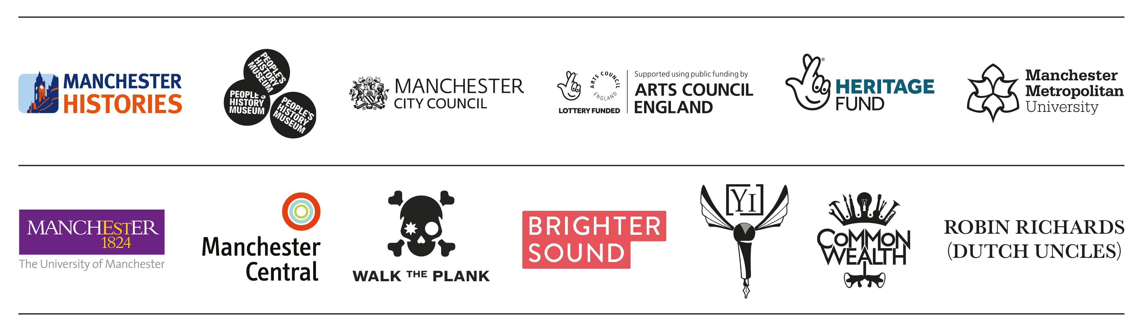

Peterloo 2019 partners
